2019 Oklahoma Prince Hall Foundation, INC
Charity Golf Tournament
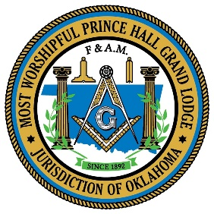

Dear Sponsor(s)
On Saturday September 14, 2019 the Oklahoma Prince Hall Foundation, INC., will be holding its 2nd Annual Charity Golf Tournament at the John Conrad Golf Course, 711 South Douglas Blvd, Midwest City, Oklahoma. With your help we will be able to raise a generous amount of money for the many charity programs The Foundation is associated with.
You can help in the cause by sponsoring a hole. We have created a variety of sponsorship levels for you to choose from. Please consider making a gift today in support our projects, such as the Lupus Program, Disaster Relief and our annual scholarship program which (The Grand Lodge gave out over twenty-five ($25,000) thousand dollars last year). All proceeds from the sponsorship will directly benefit these program and other charity events.
A sign with your logo will be placed at a select hole, along with your company name put on the tournament website. A list of sponsors will be given out before the tournament starts and again at the luncheon.
If you are unable to provide support through a monetary donation, items for door prizes would be greatly appreciated and beneficial to the success of this event.
Bronze Sponsorship $100 Platinum Sponsorship $500
Silver Sponsorship $175 Titanium Sponsorship $1000.00
Gold Sponsorship $250
Titanium Sponsors have exclusivity at their hole and the opportunity for additional signage.
I/We are unable to be a sponsor at this time, but would like to make a gift of $_________
Contact Name: ________________________________________________________________
Phone Number: ______________________ Email: ____________________________________
Please indicate below what you would like to appear on the sign. (Please Print Clearly)

__________________________________________________________________________________________
Make all checks/Money Order payable to: Oklahoma Prince Hall Foundation, INC,
Mail to: Lee McCullum 1701 Haven Drive Midwest City, OK 73130 Telephone: (405)-623-8075
On behalf of our M.W. Grand Master and the Most Worshipful Prince Hall Grand Lodge, F&AM, PHA,
Thank you for helping us make a difference in the life of people in need.

